**Enhancing Feature Engineering with Large Language Models through Causal Feature Engineering & Feature Selection**

**By:** Yuval Saadaty

## **Abstract**

Feature engineering is essential but challenging in data science, often requiring extensive domain knowledge. Our research aims to simplify this process by using large language models (LLMs) instead of human expertise, enhancing feature generation through automation and feature selection.

Our method builds on the approach in "Large Language Models for Automated Data Science: Introducing CAAFE for Context-Aware Automated Feature Engineering," where GPT-3.4 and GPT-4 adapt feature engineering based on dataset descriptions to replace human domain knowledge. We evaluate features using accuracy and ROC curve scores, only retaining those that enhance model performance.

Unlike the referenced paper, we use Gemini-2.0-flash to aggregate all new features, regardless of immediate improvements, hypothesizing that some may be beneficial when combined with others. We ignore LLM suggestions to remove columns, keeping all possible features for comprehensive analysis.

Our experimental approach includes three phases:

1. **First Experiment:** Apply only feature selection methods and then evaluate the model.
2. **Second Experiment:** Conduct causality analysis on the features, retaining only those with a causal estimate greater than 0.1. Then, apply feature selection methods to these selected features.
3. **Third Experiment:** First apply feature selection methods, and then conduct causality analysis on the selected features.

The first experiment achieved the highest accuracy, surpassing the results reported in the original paper. Subsequent experiments incorporating causality before or after feature selection resulted in a decrease in accuracy. We used the latest TabPFNClassifier for compatibility and conducted comparative analyses to validate our approach.

## **Problem Description**

### **What Element in the DS Pipeline Are We Improving?**

Feature engineering, the process of creating meaningful features from raw data, remains a bottleneck due to its reliance on domain expertise. Existing automated solutions have sought to alleviate these challenges. Notably, advancements in large language models (LLMs) have paved the way for new methodologies. These models can analyze extensive datasets and generate innovative features without direct human oversight

**Challenges**

* Feature engineering is often domain-dependent and requires expert intuition.
* Traditional feature selection methods can capture correlations but do not guarantee causality.

Solution overview:

The classifier mentioned in the original paper utilized an older version of the TabPFNClassifier. I encountered difficulties running this older version, so I opted to use the latest version, which yielded different results from those shown in the paper. Consequently, my initial step was to evaluate the four datasets using the original code. Additionally, I was unable to use the GPT API, so the results presented here are derived from using the Gemini-2.0-flash model.

|  | Baseline Results | | Current Experiment Results | |
| --- | --- | --- | --- | --- |
| Dataset | No Feat. Eng. | CAAFE (Gemini-2.0-flash) | No Feat. Eng. | CAAFE (Gemini-2.0-flash) |
| cmc | 0.7375 | 0.7393 | 0.5962 | 0.5907 |
| diabetes | 0.8427 | 0.8434 | 0.7917 | 0.7969 |
| eucalyptus | 0.9319 | 0.9319 | 0.7228 | 0.7337 |
| airlines | 0.6211 | 0.6203 | 0.642 | 0.6203 |

Table 1: the performance metrics for various datasets, comparing baseline and current experiment results with and without feature engineering.

The second step in our research involved modifying the original CAFFE model code to aggregate all possible feature combinations suggested by the LLM output. Unlike the original approach where only feature additions that improved the ROC curve score and accuracy were aggregated, my approach was to aggregate all potential new features after 5 epochs, disregarding the LLM's suggestions for feature removal. Subsequently, causality analysis and feature selection were applied to retain features with causal relationships and significant impact on the model.

Figure 1 displays the total number of features against the method applied to the CMC dataset. The x-axis represents the count of features, and the y-axis the method applied. The original features of the CMC dataset are as follows:

1. Wife's age (numerical)
2. Wife's education (categorical) 1=low, 2-3, 4=high
3. Husband's education (categorical) 1=low, 2-3, 4=high
4. Number of children ever born (numerical)
5. Wife's religion (binary) 0=Non-Islam, 1=Islam
6. Wife's current employment status (binary) 0=Yes, 1=No
7. Husband's occupation (categorical) 1-4
8. Standard-of-living index (categorical) 1=low, 2-3, 4=high
9. Media exposure (binary) 0=Good, 1=Not good
10. Contraceptive method used (class attribute) 1=No-use, 2=Long-term

In the original CAFFE model application, only one new feature was added—'Age_Children_Interaction', calculated by multiplying the wife's age by the number of children she has ever given birth to. This new feature is represented in the code as df['Age_Children_Interaction'] = df['Wifes_age'] * df['Number_of_children_ever_born']. Consequently, in Figure 1, the 'CAFFE selected features' count is 11, reflecting the original 10 features plus one new feature.

In our experiments, we generated 9 additional features from the LLM output over 5 epochs, which are:

* 'Age_Education': Wifes_age * Wifes_education
* 'Education_Difference': Husbands_education - Wifes_education
* 'Children_Age': Number_of_children_ever_born * Wifes_age
* 'Working_Occupation': Wifes_now_working? * Husbands_occupation
* 'Religion_Education': Wifes_religion * Wifes_education
* 'Wifes_age_squared': Wifes_age**2
* 'Combined_education': Wifes_education + Husbands_education
* 'Occupation_living_interaction': Husbands_occupation * Standard-of-living_index
* 'Working_media_interaction': Wifes_now_working? * Media_exposure

Therefore, in Figure 1, the 'Generated Features (All)' bar shows a total of 19 features, comprising the original 10 plus the 9 new features created from the LLM in 5 epochs.

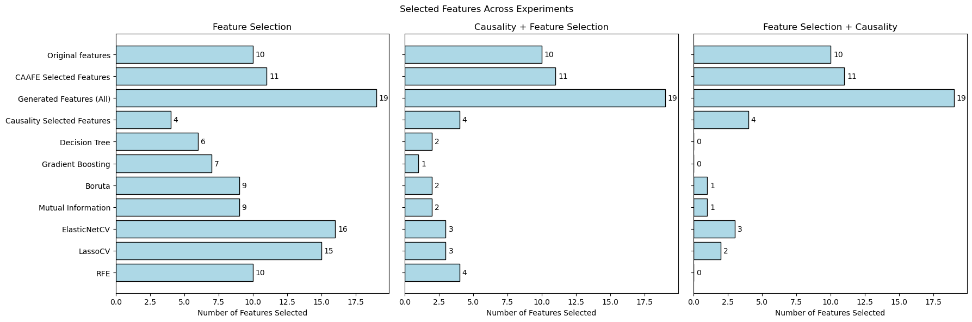

Figure 1: The three panels from left to right illustrate the number of features selected in cmc dataset, using different methods: the first panel shows feature selection only, the second combines causality analysis with feature selection, and the third applies feature selection followed by causality analysis.

The third step in the research involved conducting the first experiment, which included applying feature selection methods and evaluating all newly generated features.

### **Experiment 1: Evaluating Feature Selection**

* **Hypothesis:** Iterative refinement using feature selection methods improves model performance.
* **Process:**
  1. Extract dataset metadata.
  2. Generate features using LLMs.
  3. Filter features using features selection methods.
  4. Train TabPFNClassifier on selected features.
  5. Evaluate using Accuracy.

The feature selection methods used were:

* **Recursive Feature Elimination (RFE)**: Iteratively removes the least important features.
* **LassoCV**: Employs L1 regularization to eliminate unimportant features.
* **ElasticNetCV**: Combines L1 and L2 regularization to improve feature selection.
* **Mutual Information**: Measures the information gain between features and the target variable; it achieved the best accuracy across datasets.
* **Boruta**: A feature selection algorithm based on Random Forest importance scores.
* **Gradient Boosting**: Identifies the most relevant features based on boosting techniques.
* **Decision Tree**: Selects features based on their contribution to tree splits.

In Figure 1, the left plot shows the number of features selected by each method. RFE selected 10 features from the total of 19; LassoCV selected 15; ElasticNetCV selected 16; Mutual Information and Boruta each selected 9; Gradient Boosting selected 7; and Decision Tree selected 6. Figure 2 plots the names of the features selected by each method in each experiment.

The second experiment involved using all generated features, applying causality analysis, and retaining only those features with a causal estimate greater than 0.1. Then, the aforementioned feature selection methods were applied to these causally significant features.

### **Experiment 2: Evaluating Causal and then Feature Selection**

* **Hypothesis:** Features identified through causal inference will enhance model generalization.
* **Process:**
  1. Extract dataset metadata.
  2. Generate features using LLMs.
  3. Filter features using causal inference techniques.
  4. Filter features using features selection methods.
  5. Train TabPFNClassifier on selected features.
  6. Evaluate using Accuracy.

In the third experiment, all feature selection methods were applied first, and causality analysis was then conducted on the selected features, retaining only those with a causal estimate greater than 0.1.

### **Experiment 3: Evaluating Feature Selection and then Causal**

* **Hypothesis:** Features identified through causal inference will enhance model generalization.
* **Process:**
  1. Extract dataset metadata.
  2. Generate features using LLMs.
  3. Filter features using features selection methods.
  4. Filter features using causal inference techniques.
  5. Train TabPFNClassifier on selected features.
  6. Evaluate using Accuracy.

Figure 1 displays the number of selected features after each experiment and method. In the second experiment, the middle plot shows a bar named "Causality Selected Features," representing the number of features selected after causality analysis and before feature selection. Therefore, all bars below this represent features that underwent additional feature selection, likely resulting in the same or a reduced number of selected features.

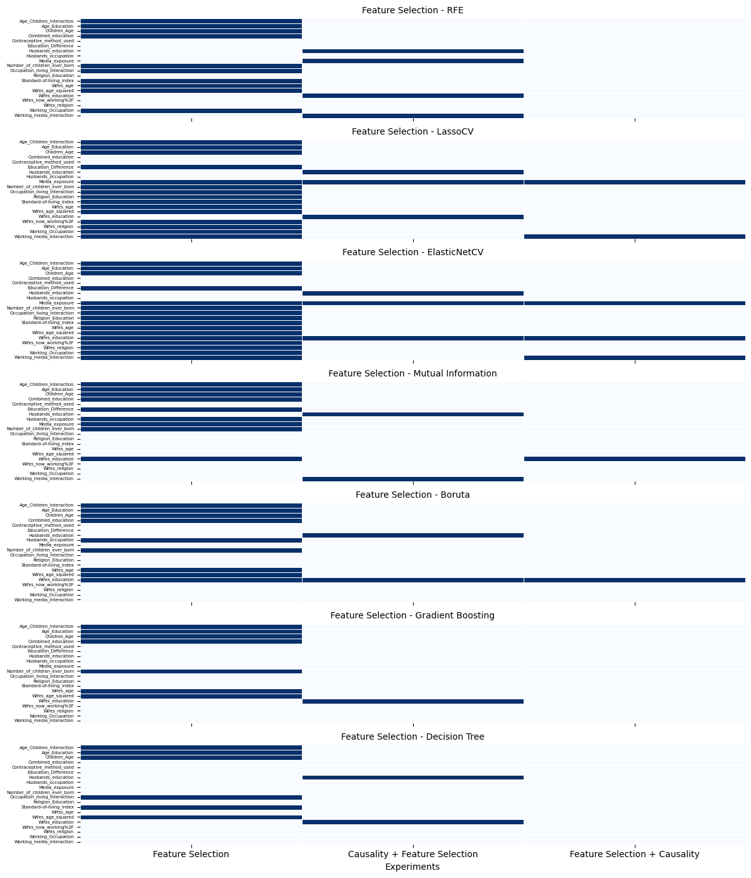

Figure 2: results of various feature selection methods applied to a cmc dataset

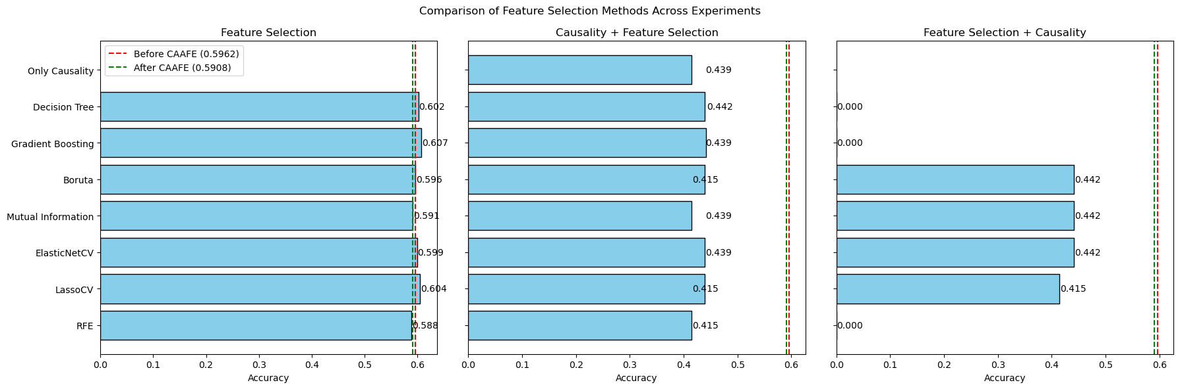Figure 3: Comparison of accuracy scores across different feature selection methods in three experiments using the CMC dataset.

Experimental evaluation:

In Figure 3, we observe the results from each experiment on the CMC dataset, where we note that Experiment 1, the left plot, using Gradient Boosting achieved the highest accuracy (0.607), surpassing the original CAAFE method which recorded an accuracy of 0.5907. Figure 5 also illustrates differences in feature selection, highlighting that Gradient Boosting selected 7 features not considered by the original CAAFE approach, as evaluating them individually did not enhance accuracy. The results presented in Figures 3 and 4 are based on the CMC dataset.

The middle plot presents results from an experiment where causality analysis was applied first, followed by feature selection. The initial accuracy achieved solely through causality analysis was 0.439, as indicated by the first bar labeled "Only Causality." This phase significantly constrains the feature space by retaining only causally relevant features, which inherently limits the potential accuracy improvements that subsequent feature selection methods can achieve.

In some benchmarks within this experimental setup, no features achieved a causal estimate greater than 0.1. Consequently, no features were selected, and the experiment had to be terminated prematurely because feature selection methods cannot be applied without any initial features. This resulted in cases where the accuracy could not be improved beyond the initial causality analysis, explaining the consistently lower accuracy scores across all methods in the middle plot compared to those in the left plot, where the average accuracy of the first experiment using various feature selection methods was approximately 0.5981.

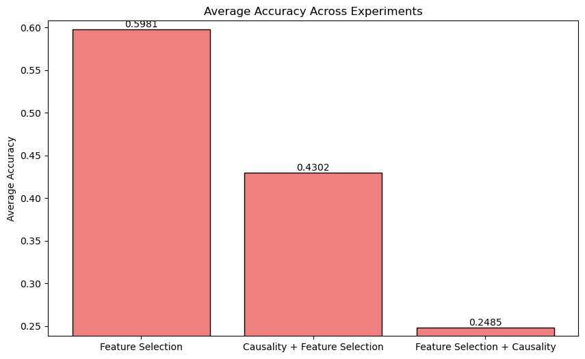

Figure 4: the average accuracy across three different experiments conducted on the CMC dataset

This highlights the challenge of relying solely on causality to determine feature relevance, especially when stringent thresholds lead to no features being selected, thus restricting the potential for any subsequent analytical enhancements through feature selection methods.

The right plot displays the third experiment, which involved applying feature selection methods first and then causality analysis. This sequence led to lower accuracy compared to the first experiment. Additionally, in some cases after applying causality, no features achieved a causal estimate greater than 0.1, resulting in an empty bar on the plot because the evaluation was halted; it's not possible to evaluate the accuracy of zero features.

The diminished results observed in the second and third experiments, where causality was used either before or after feature selection, were consistent across all four benchmarks tested. Since the incorporation of causality significantly reduced accuracy across all benchmarks, I will focus exclusively on examining the accuracy of the first experiment across all benchmarks.

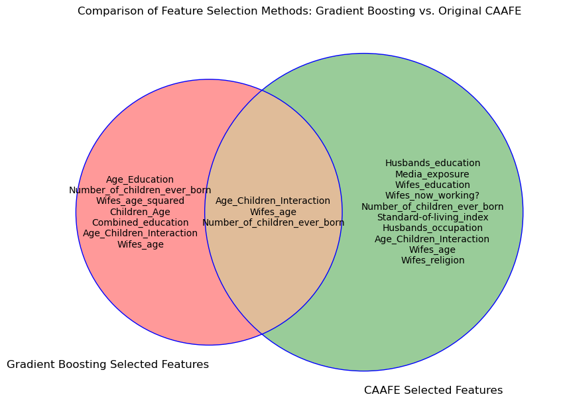

Figure 5: compares the features selected by Gradient Boosting and Original CAAFE, illustrating both unique and shared feature selections between the two methods for feature selection.

Overall, we observe that utilizing all potential new features generated by the LLM and then applying feature selection methods resulted in better outcomes compared to the approach suggested in the CAAFE model. As shown in Table 2, across all four benchmarks, our method achieved the same or better results than the original CAAFE approach.

| **Dataset** | **Best Feature Selection Method** | **Feature Selection Accuracy** | CAAFE (Gemini-2.0-flash) **Accuracy** |
| --- | --- | --- | --- |
| CMC | Gradient Boosting | **0.607** | 0.5907 |
| **Diabetes** | Mutual Information | **0.8177** | 0.7969 |
| **Eucalyptus** | Decision Tree | **0.734** | 0.734 |
| Airlines | Boruta | 0.652 | 0.642 |

### **Table 2: the accuracy of different feature selection methods against the CAAFE method and out feature selection method across four datasets: CMC, Diabetes, Eucalyptus, and Airlines.**

### **Figure 6:** The three panels from left to right illustrate the number of features selected in **Diabetes** dataset, using different methods

### **Figure 7:** The three panels from left to right illustrate the number of features selected in **Eucalyptus** dataset, using different methods

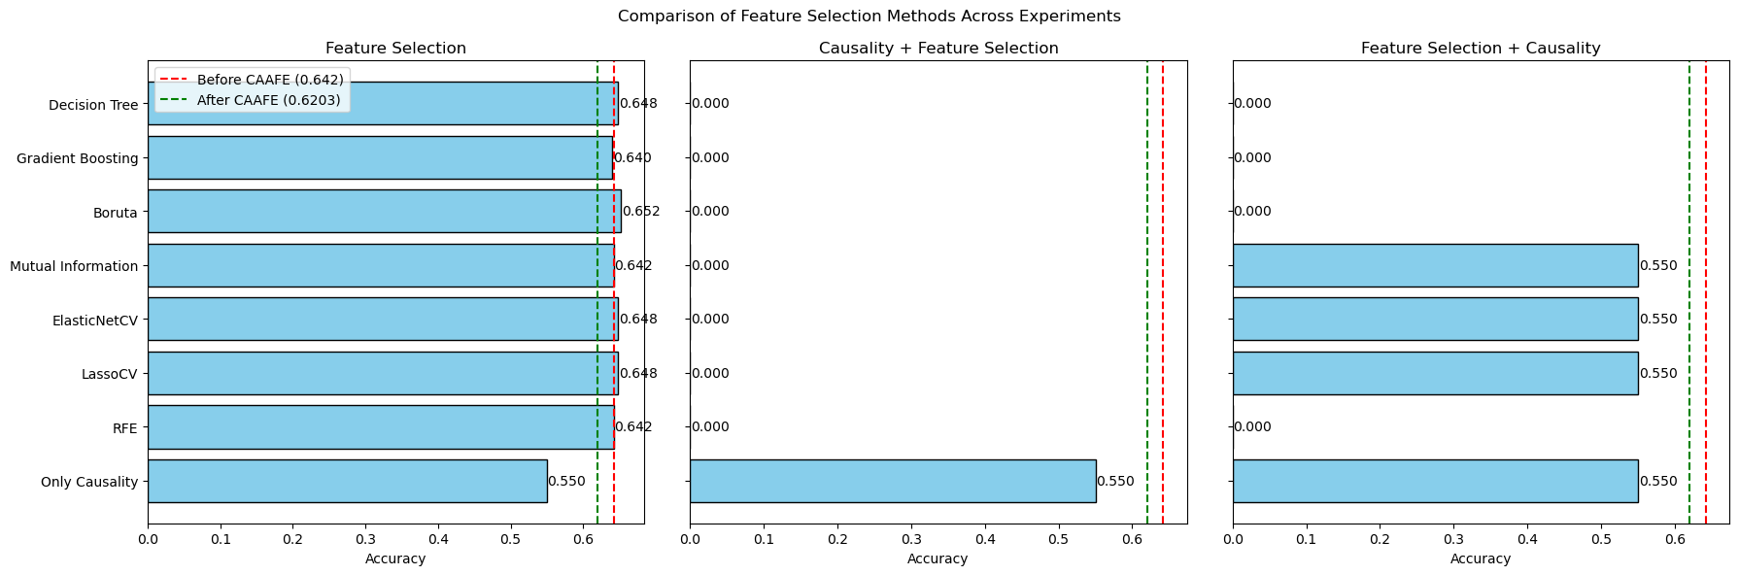

### **Figure 8:** The three panels from left to right illustrate the number of features selected in Airlines dataset, using different methods

### **Related Work**

* **Large Language Models for Automated Data Science: Introducing CAAFE for Context-Aware Automated Feature Engineering** – This work introduced the use of Large Language Models (LLMs) for automated feature generation, but it did not incorporate causal filtering. Our approach builds upon this by utilizing all features generated by the LLM, as opposed to their method of selectively adding features only if they demonstrate accuracy improvements. We extend their framework by applying both feature selection and causality analysis to all generated features. Our methodology was indeed inspired by their initial use of LLMs for feature creation.
* **Optimized Feature Generation for Tabular Data via LLMs with Decision Tree Reasoning** – This study employs decision trees to evaluate features generated by LLMs but does not incorporate causality in its analysis. In contrast, our method uses a modified version of the CAAFE code for feature generation and introduces an iterative process where feature improvement is continuously sought from the LLM, utilizing more advanced models. This iterative enhancement inspired us to manipulate the generated features more extensively.
* **Automated Feature Engineering Using Causal Inference** – While this research focuses on applying causality in feature engineering, it does not leverage LLMs for the generation of features. Our solution differs by integrating causality with LLM-driven feature generation, thereby enriching the potential for uncovering meaningful patterns. We drew inspiration from their causal approach to apply a similar methodology to the LLM-generated features.

## **Conclusion**

Throughout this research, we examined three experiments to assess different feature selection methodologies integrated with causal analysis. Our findings indicate that the first experiment, which solely utilized feature selection methods, achieved the highest results. This outcome underscores the effectiveness of direct feature selection strategies over combined approaches with causality in enhancing model performance.

While attempting to improve the CAAFE approach by integrating feature selection and causality, we observed that causality analysis often decreased model accuracy. This reduction in performance highlights a potential trade-off between employing causally relevant features and achieving optimal accuracy. In future studies, alternative methods to incorporate causality into the model development process should be explored, potentially leading to more robust models that maintain high accuracy while incorporating causal insights.

This project provided valuable insights into using Large Language Models (LLMs) as a domain knowledge substitute for human-driven feature engineering. The results confirmed that LLMs could effectively enhance model outcomes, underscoring their potential in automating and improving feature engineering processes. However, the application of causality, while ensuring features have a reasoning relationship with the labels rather than mere correlations, significantly impacted the model's accuracy. This raises an important question encountered during the research: Should we prioritize features that ensure high model accuracy, or should we opt for features with high causal relevance that might lead to better generalization on new or larger datasets?

Given that the datasets used from CAAFE were limited to small samples, up to 2,000 in total, it would be prudent to test the impact of causal features on larger datasets in future studies. There is a possibility that features with genuine causal relationships could demonstrate improved generalization capabilities on broader datasets, potentially validating the causal approach's efficacy in realistic settings.